**Object Oriented Analysis And Design**

**UE19CS353**

**6th Semester, Academic Year 2021-22**

Week #: 1 - Java Programming

Date: 2/2/2022

|  |  |  |
| --- | --- | --- |
| Name :  SUMUKH RAJU BHAT | SRN :  PES1UG19CS519 | Section :  H |

Code:

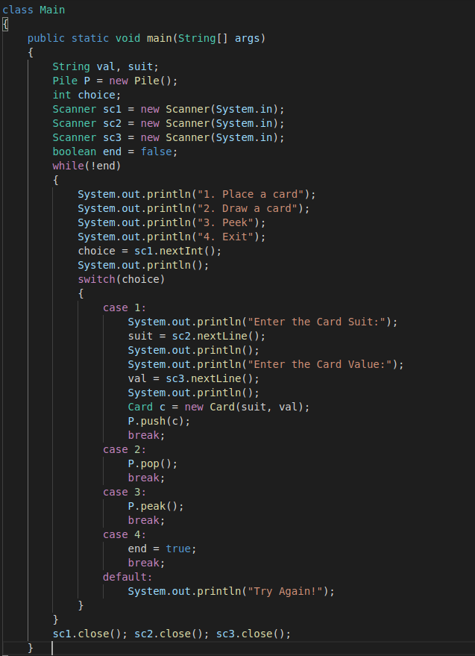

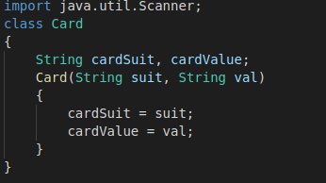

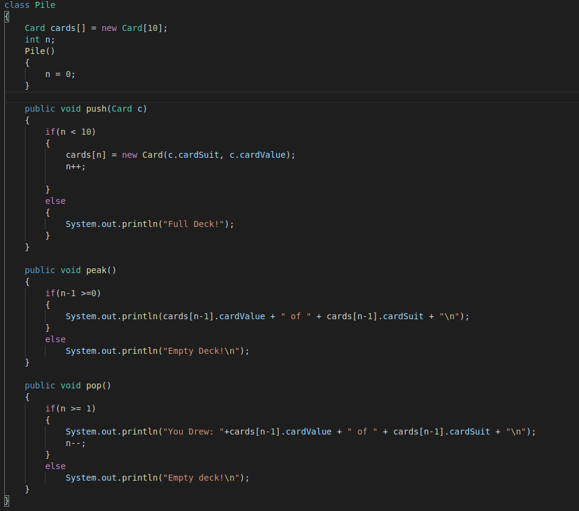

Screenshots:

